Brownfields 2019 Influencer Kit

Everything You Need to Share the Excitement of #Brownfields2019!

Dear Brownfields 2019 Influencer,
Thank you for your willingness to help the EPA and ICMA promote the 2019 National Brownfields Training Conference. We are grateful for your help in getting the word out and generating excitement around this year’s conference.
This Influencer Kit will help you promote the conference through social media, your organization’s media outlets (newsletters, articles, etc.), and any other channels where we can spread the word! Knowing that partnering individuals and organizations substantially contribute to the overall success of the National Brownfields Training Conference, we want to give you all the tools you need to help us!
Below, you’ll find sample copy for newsletters/articles/blogs, sample tweets and Facebook posts, links to our social media pages, a list of important Brownfields website links, and graphics. This kit is easy to use- just copy, paste, and go! Graphics can be saved to your computer so you can use them on your channels.
If there are other content items that would be helpful for you, please let us know. We’re happy to provide more copy and graphics.
We will be sending additional copy and graphics as we get closer to the conference.
If you have any questions, please email rdesantis@icma.org or asabur@icma.org.
Thanks,
ICMA Brownfields 2019 Outreach Team

Brownfields 2019 Social Media Links

Facebook: https://www.facebook.com/brownfields2019/
Twitter: @Brownfields2019
LinkedIn: National Brownfields Training Conference (https://www.linkedin.com/groups/48491/)

Sample tweets

For Registration
- The National Brownfields Training Conference is BACK! Join us for the largest gathering of brownfields professionals in the world at #Brownfields2019 in LA this December! https://brownfields2019.org/
- We're proud to announce our partnership with @Brownfields2019 for the National Brownfields Training Conference taking place in Los Angeles! Learn more here: https://bit.ly/2IAyesD
- Mark your calendars & join us for @Brownfields2019 Dec. 11-13 in Los Angeles and join us for 3 days of training and networking. https://bit.ly/2Kb0eTz
- We’re counting down the days until @Brownfields2019! Don’t miss your chance to join. Register and book your housing today! https://bit.ly/2Kb0eTz
- Learn how redeveloping #brownfields can help revitalize your community. Join us for @Brownfields2019 this December. https://bit.ly/2Kb0eTz
- Explore the City of Angels and learn the many ways #brownfields redevelopment can support your community. Join us for @Brownfields2019 this December! https://bit.ly/2Kb0eTz

For Educational Content
- We’ll see you at #Brownfields2019! Join us for 3 days of high-quality learning experiences and peer-to-peer engagement in #LA! Save your spot today! https://bit.ly/2Kb0eTz
- Join us for @Brownfields2019! With +100 educational sessions, a vibrant exhibit hall, and activities located in the heart of downtown #LA, this is one experience you won’t want to miss. https://bit.ly/2Kb0eTz
- Share your stories and stimulate new ideas for the future of #brownfields redevelopment. Join us for #Brownfields2019 in Los Angeles this December!

“I’m Attending!”
- Are you ready for the premier event for #brownfields professionals? See why we’re excited about our recent partnership with @Brownfields2019
- It’s official- we’re headed to @Brownfields2019! Mark your calendars and join us for three days of training, networking and business development!
- We’ll see you there! @Brownfields2019 Registration is officially open. Don’t delay- save your spot today! https://bit.ly/2Kb0eTz
- We just signed up to be a part of the largest gathering of #brownfields professionals there is. Meet us at @Brownfields2019 this December in Los Angeles! https://bit.ly/2Kb0eTz

Sample Facebook Posts

For Registration
- Join us December 11-13, 2019 for 3 days of learning, networking, and exploration. Register now for @Brownfields2019, the premier conference for land revitalization & redevelopment stakeholders. https://bit.ly/2Kb0eTz
- If you are looking to revitalize your community, spur economic growth, restore the environment, and protect the public health, then don’t miss @Brownfields2019. Join us December 11-13 for 3 days packed with learning, networking, and exploration at the Los Angeles Convention Center. https://bit.ly/2Kb0eTz
- Registration and housing are now OPEN for the 2019 National Brownfields Training Conference! Learn innovative ways to tackle #brownfields challenges in your community. Register today! https://bit.ly/2Kb0eTz

For Educational Content
- Join us for an array of hands-on workshops, thought-provoking sessions, engaging networking opportunities, and much more! See why we couldn’t wait to register for @Brownfields2019. https://bit.ly/2Kb0eTz
- #Brownfields2019 is the premier event for promoting P3s to stimulate #communityrevitalization and sustainable brownfields redevelopment. Meet us in #LA and join the conversation!

“I’m Attending!”
- We’ll see you there! @Brownfields2019 Registration and Housing is officially open. Don’t delay- Register and book your housing today! https://bit.ly/2Kb0eTz
- We just signed up to be a part of the largest gathering of #brownfields professionals there is. Meet us at @Brownfields2019 this December in Los Angeles! https://bit.ly/2Kb0eTz

Sample Newsletter Text

Join us for the 2019 National Brownfields Training Conference, December 11-13, with pre-conference programming on December 10 in Los Angeles, CA. Featuring dozens of educational sessions and mobile workshops including many showcasing the City of Angels and the redevelopment in the surrounding region, the educational programming offered by the conference has something for both beginners and seasoned professionals. Register for the conference and book your hotel at https://brownfields2019.org/.

Join us for the National Brownfields Training Conference, December 11-13, 2019, with pre-conference programming on December 10 in Los Angeles, California. The dynamic educational program features speakers, engaging topics, mobile workshops and more to train you through case study examples, interactive learning experiences and discussions. Register for the conference and book your hotel stay now!
Are you ready for Brownfields 2019? Register today! The National Brownfields Training Conference is taking place December 11-13, 2019, with pre-conference training on December 10, at the award-winning Los Angeles Convention Center. Come learn from and network with experts in the industry!

Important Links
Homepage: https://brownfields2019.org/
Registration Page: https://brownfields2019.org/register/
Housing Page: https://brownfields2019.org/housing/
Educational Sessions: https://brownfields2019.org/education/
Exhibitor Information: https://brownfields2019.org/exhibit/
Sponsor Information: https://brownfields2019.org/sponsorship/
Blog (for the latest updates): https://brownfields2019.org/blog/

Graphics

Facebook
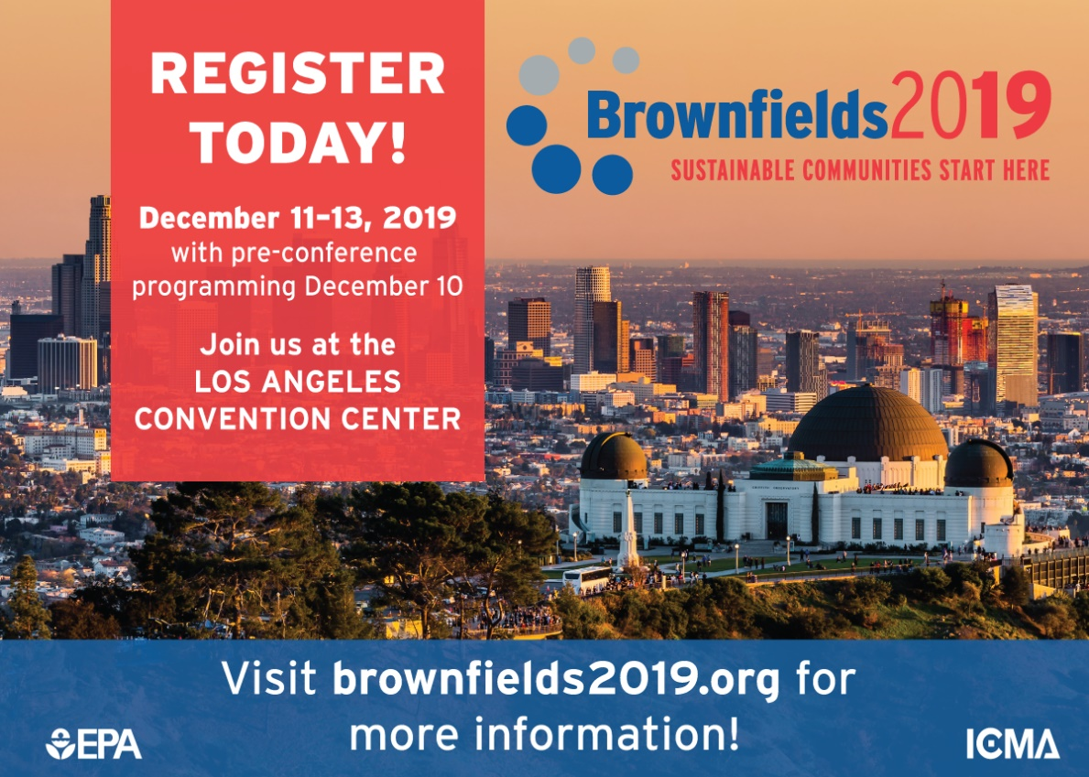

Twitter
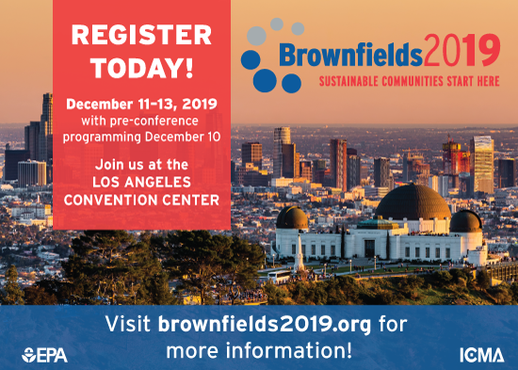

Logo
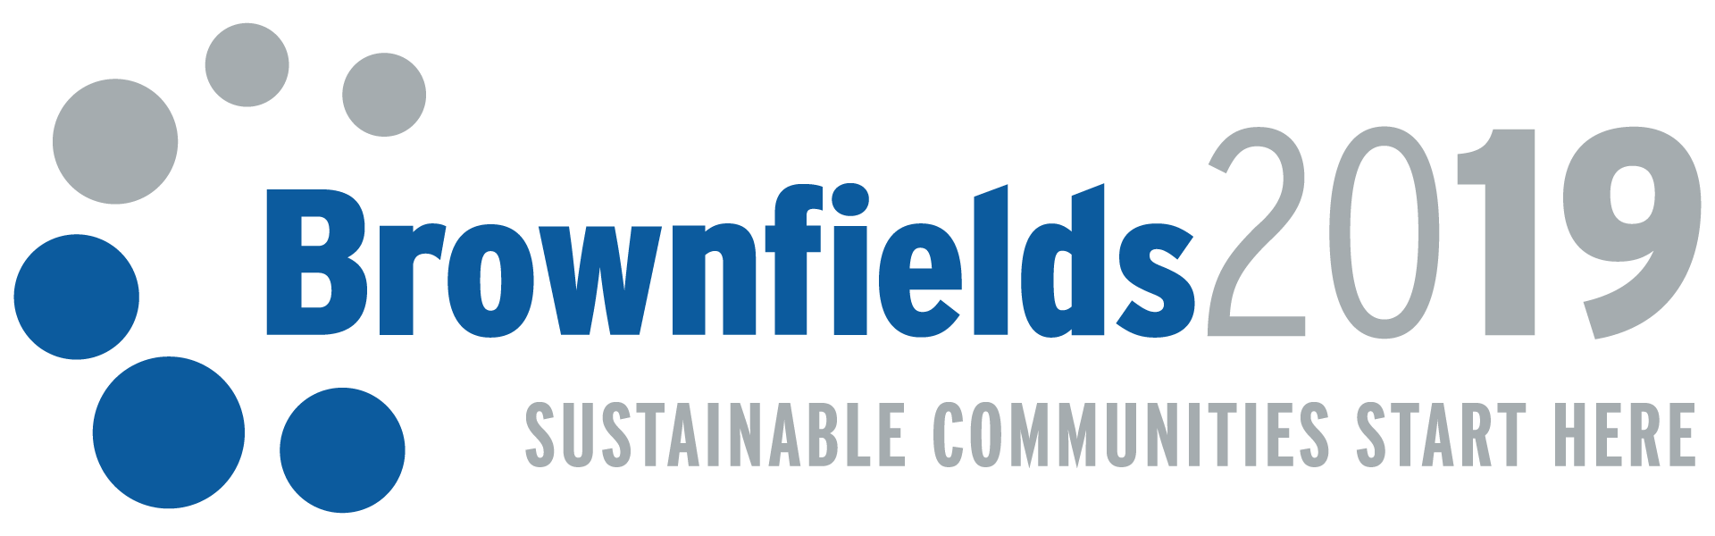

Signature Graphic
